Today we will learn...

1. What are the Prerequisites

2. How to create maven project in Eclipse

3. Add dependencies in pom.xml

4. Make project ready for adding Selenium scripts

Prerequisites

Java is installed on your system

Eclipse is installed on your system

Maven is installed on your system

References:

<https://mvnrepository.com>

<http://www.seleniumhq.org>

# Comprobar versión java

Cmd/java –version

Cmd/ javac –version

# Crear proyecto maven

File-new –others-maven Project: simple Project ,workspace – insertar groupID (grupo)y artifactory(nombre del proyecto)

# Soporte

Seleccionar el proyecto particular del workspacio

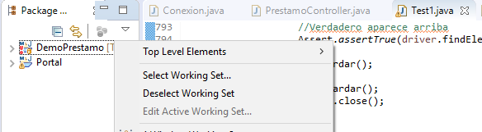

# Agregar dependencias

Agregar: Maven repository : Selenium java (340) - junit (4.12)

---Dependencies

.buscar dependencies-buscar maven repository-add insertar : group , artifactory , descripcion

Otra forma

Selenium.org(db)-download-selenium

----Pom.xml : buscarlas en maven repository

<dependecies>

<dependency>

Insertar la dependencia

</dependency>

</dependencies>

/comprobar en jar-maven projects

Clase

-Crear clase en src/test/java: browserTest

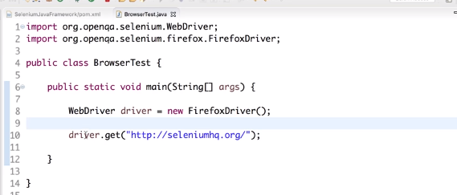

//correr: run(flecha) as java project

# **Selenium Framework for Beginners 2 | How to run Selenium tests on Firefox - Geckodriver**

1. How to add Firefox browser driver - Geckodriver

2. Run a test on Firefox browser

To add gecko driver exe

System.setProperty("webdriver.gecko.driver",” path to gecko driver exe”);

OR

System.setProperty("webdriver.firefox.marionette", “path to gecko driver exe”);

You can follow this on...

Windows and Mac

References:

https://github.com/mozilla/geckodrive...

// COMPROBAR CONSOLA

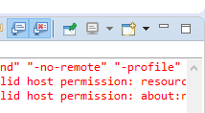

//URL GRECHO

<https://github.com/mozilla/geckodriver/releases>

buscar el 64 bits , para comprobar la configuración del sistema busco en equipo, d , propiedades

//Crear carpeta para insertar el driver

-Proyecto – new folder – insertar el geckodriver en la ruta o arrastrarlo en el proyecto

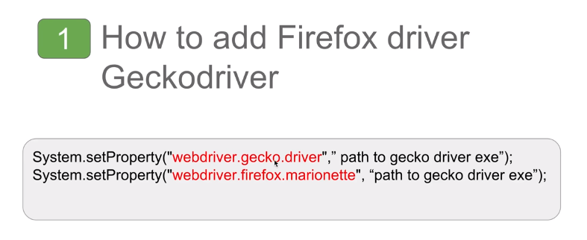

Copiar url del driver

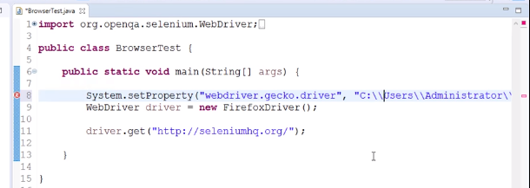



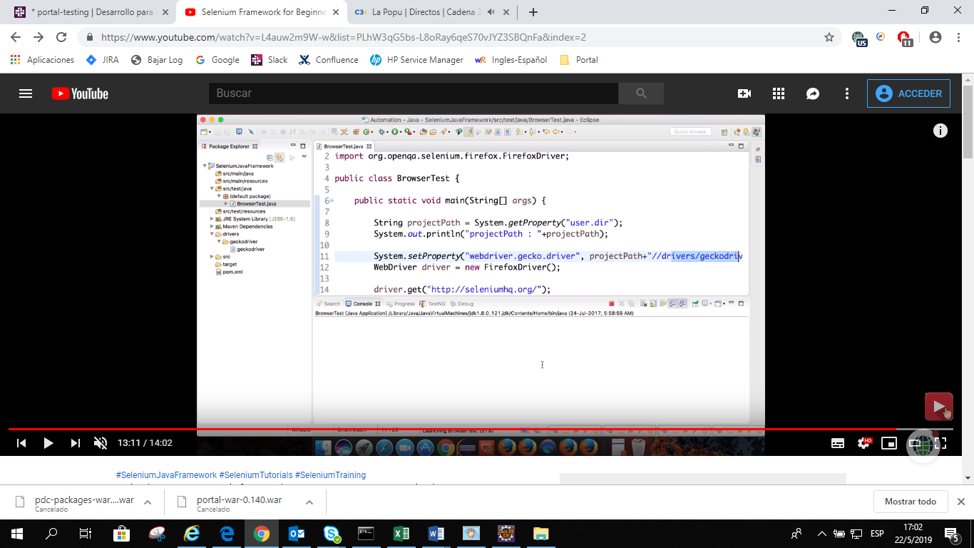

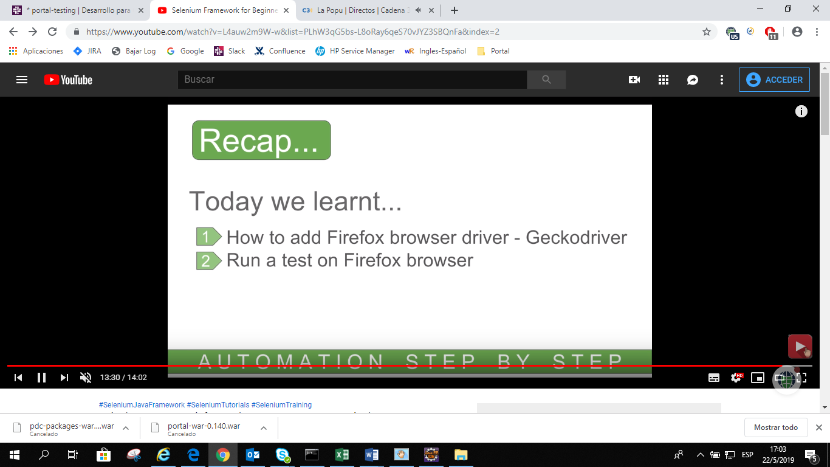

## Codigo

**package** Pack;

**import** org.openqa.selenium.WebDriver;

**import** org.openqa.selenium.firefox.FirefoxDriver;

**public** **class** PruebaMozilla {

**public** **static** **void** main(String[] args) {

String projectPath=System.*getProperty*("user.dir");

System.***out***.println("projectPath "+projectPath);//si no trae nada es null (no existe)

System.*setProperty*("webdriver.gecko.driver",projectPath+"\\Driver\\Firefox\\geckodriver.exe");

//System.setProperty("webdriver.gecko.driver","C:\\Users\\Valentino Falcucci\\Desktop\\semana 20-25\\Raghav\\AutomationStep\\Driver\\Firefox\\geckodriver.exe");

WebDriver driver=**new** FirefoxDriver();

driver.get("https://www.seleniumhq.org/");

}//clase

}//Espacio

Verificar tutoriales selenium y java??????????